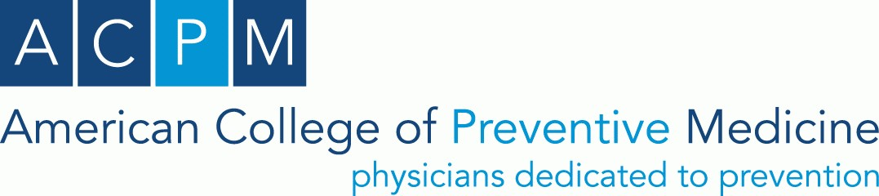

ACPM Volunteer
Conflict of Interest Disclosure Statement

Statement period: January 2024– December 2024

The meanings of the terms in this form are derived from the ACPM Conflict-of-Interest policy. Please
respond to these questions in concert with the intent of that policy. Download ACPM's complete conflict of interest policy.
- Do you, or any of your extended relations¹ (spouse, significant other, or dependent children), have any material financial interests with any company or organization doing business with (i.e., providing goods, funding, or services to) the College? If yes, please describe any business or related relationships during the statement period. As referenced by the ACCME’s new Standards for Integrity and Independence in Accredited Continuing Education, this includes financial relationships of any dollar amount.

Yes, as described below No

If yes, please describe business relationship of both you and your family member(s).

- Do you or any extended relations have a personal interest in a legal claim against the College or one of the Board members or staff members? If yes, please describe such interest below.

Yes, as described below No

If yes, please describe legal claim

1As of January 1, 2023, ACPM requires the disclosure of extended relations’ financial interest in addition to those of the volunteer. For the definition of extended relations see “AMA Conflict of Interest Policy”. Definitions. American Medical Association (AMA). Accessed November 2, 2022; https://amafoundation.org/conflict-of-interest-policy/
- During the current statement period (or prior period if this is your initial disclosure), did you, or any of your extended relations (spouse, significant other or dependent children) or any business or association with whom you are associated, receive compensation from the American College of Preventive Medicine (ACPM) for services rendered as an employee, independent contractor or otherwise? If yes, please describe below.

Yes, as described below No

If yes, please describe the relationship and compensation.

- During the statement period did you or any extended relations serve on the board or participate in a committee of any organization or corporation that conducts business or provides services to the College? If yes, please list the organization, describe its business relationship with the College, indicate your role with the organization, and describe any potential competing or conflicting interest if applicable.

Yes, as described below No

Organization Relationship with ACPM

Your role with the organization
Potential competing/conflicting interest

- During the statement period, did you or any of your extended relations offer, solicit, or accept any gift, money, benefit, loan, or other payment of any kind from any entity with whom the College does business or is considering doing business? If yes, list the gift, the person or entity from/to whom it was received/given/solicited.

Yes, as described below No

Gift Person or entity Total estimated value

Acknowledgement

I have read the American College of Preventive Medicine’s Conflict-of-Interest Policy, understand it, and agree to comply with its requirements during and, where applicable, beyond my current tenure on an ACPM committee or as an ACPM representative. I also understand that identifying and disclosing any potential conflicts of interest are ongoing obligations during my time of service to the College. I certify that the representations made in this disclosure statement are true and complete to the best of my knowledge. I recognize that any material omissions or misleading statements may result in my requirement to resign any position I may hold at ACPM.

Signed: Date: Print Name:

